Tasks to be done with CLI in this Article

﻿1. Create a key pair

2. Create a security group

3. Launch an instance using the above created key pair and security group.

4. Create an EBS volume of 1 GB.

5. The final step is to attach the above created EBS volume to the instance you created in the previous steps.

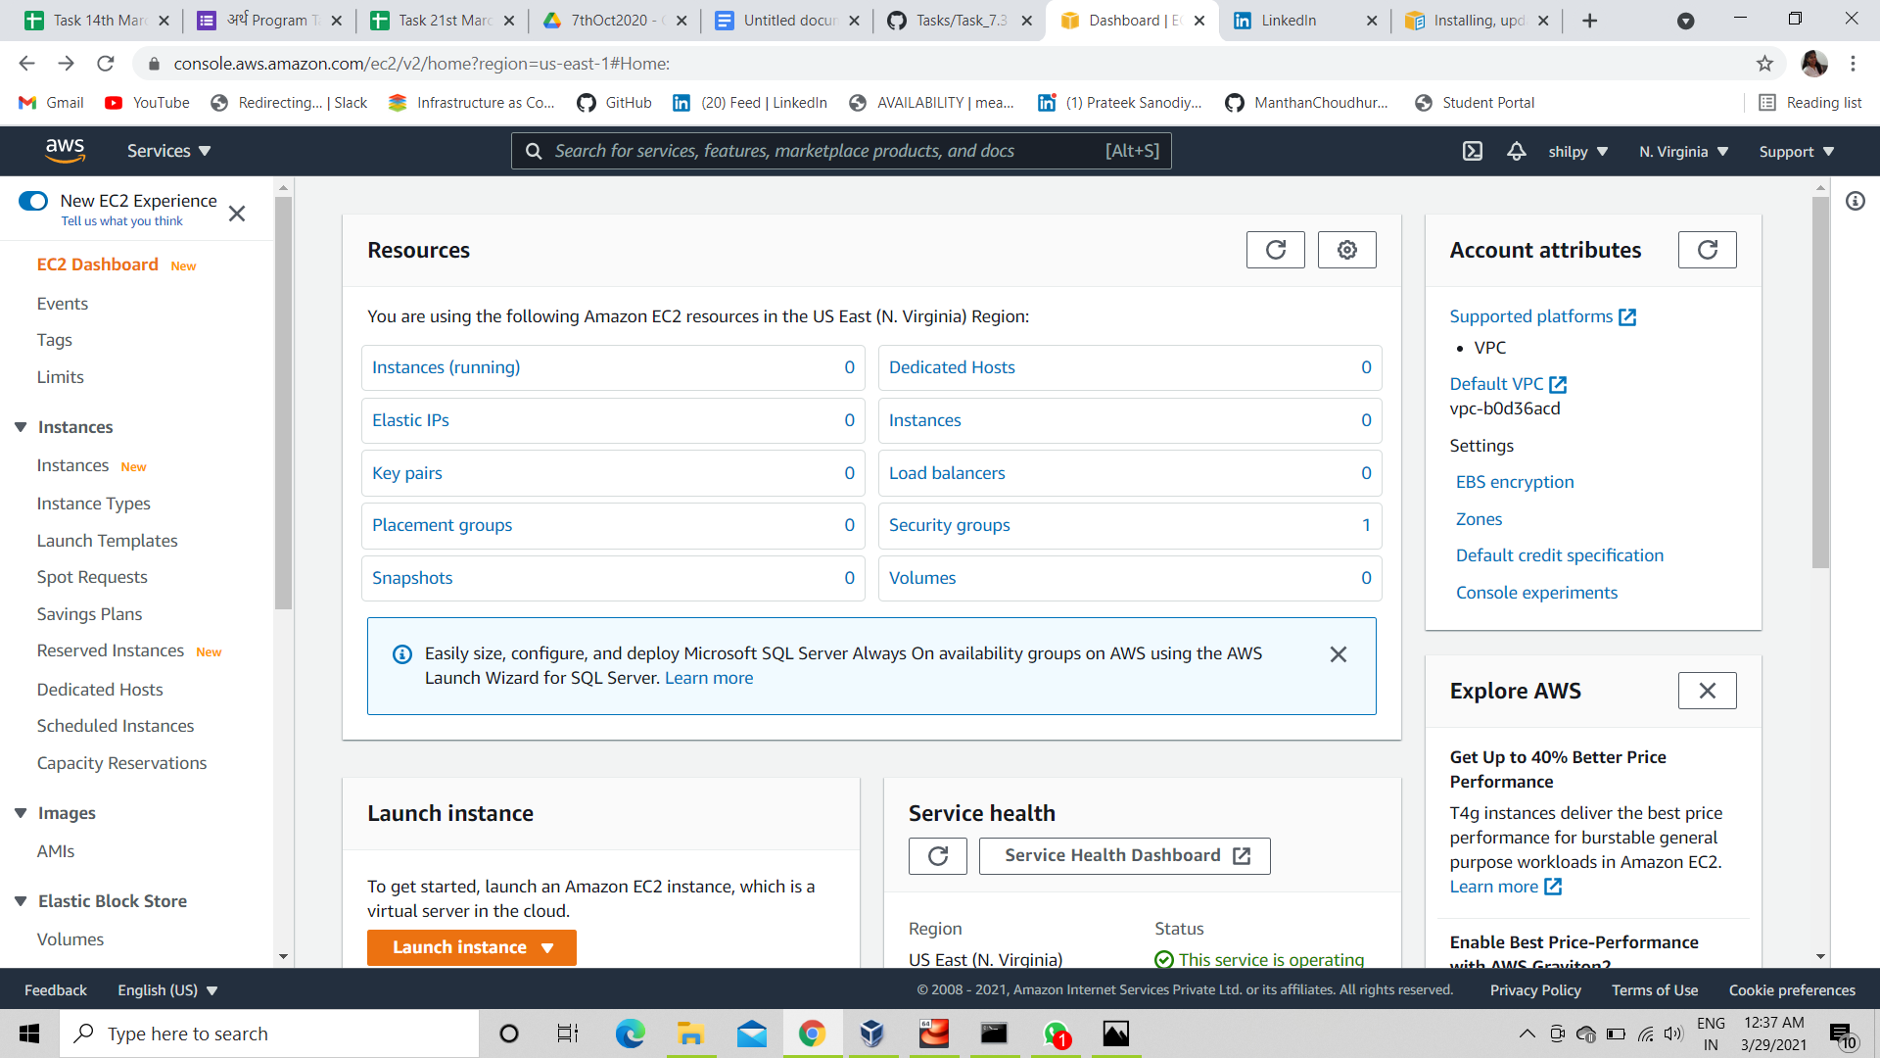

We will start from this state of 0 instances, 0 key, and all.

### **1. Create a key pair :**

As we are using AWS as ec2 user, so we have to use "aws ec2" command for using any service of AWS through CLI. And for any help , or if we will be having any doubts regarding, which all option , given command provides we can take help in command line itself with the command "aws ec2 <command> help" .

Now, if we want to create key pair, we must provide the region wherever we want to create the key, because key is regional service. here I am going to create key in north virginia (region code us-east-1).

$ aws ec2 create-key-pair --key-name keys --region us-east-1

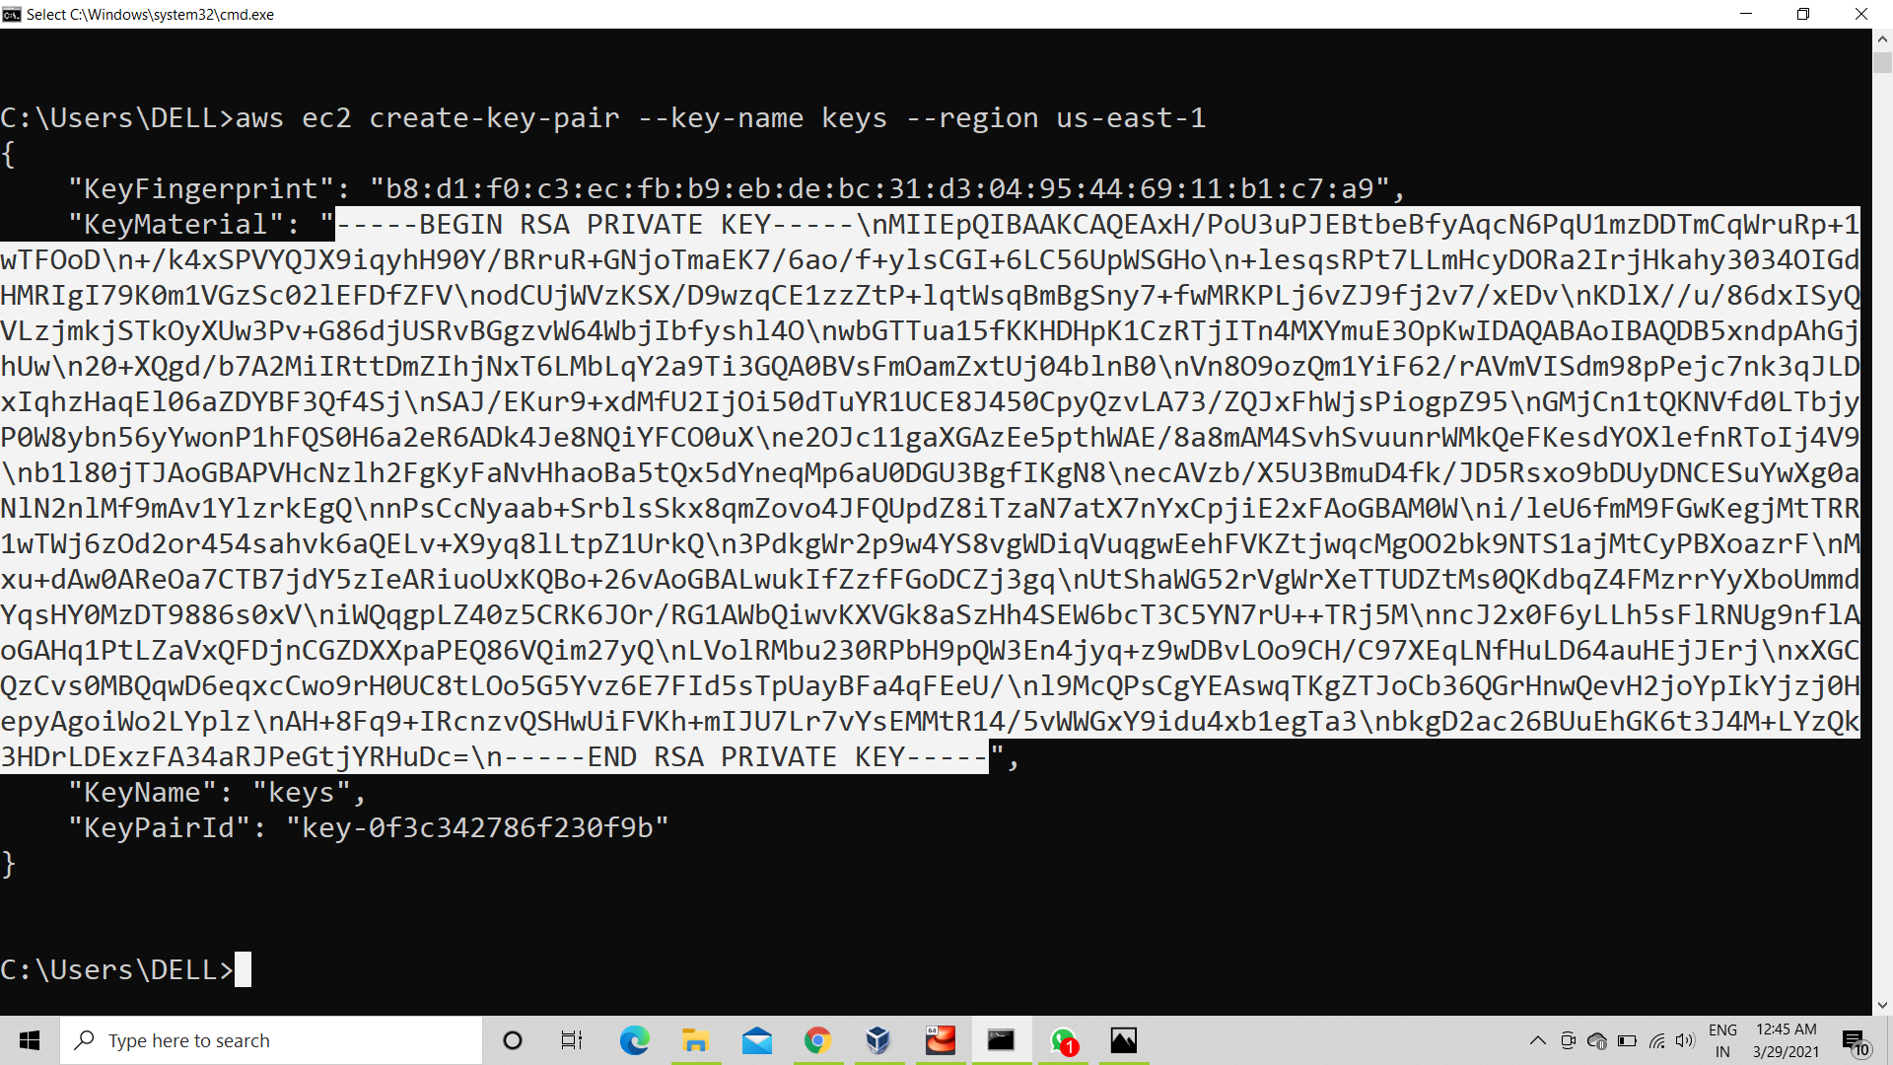

We can verify from AWS GUI portal even , that whether any key got created in N. virginia or not , also we can check from CLI with command "aws ec2 describe-key-pairs --key-name keys --region us-east-1"

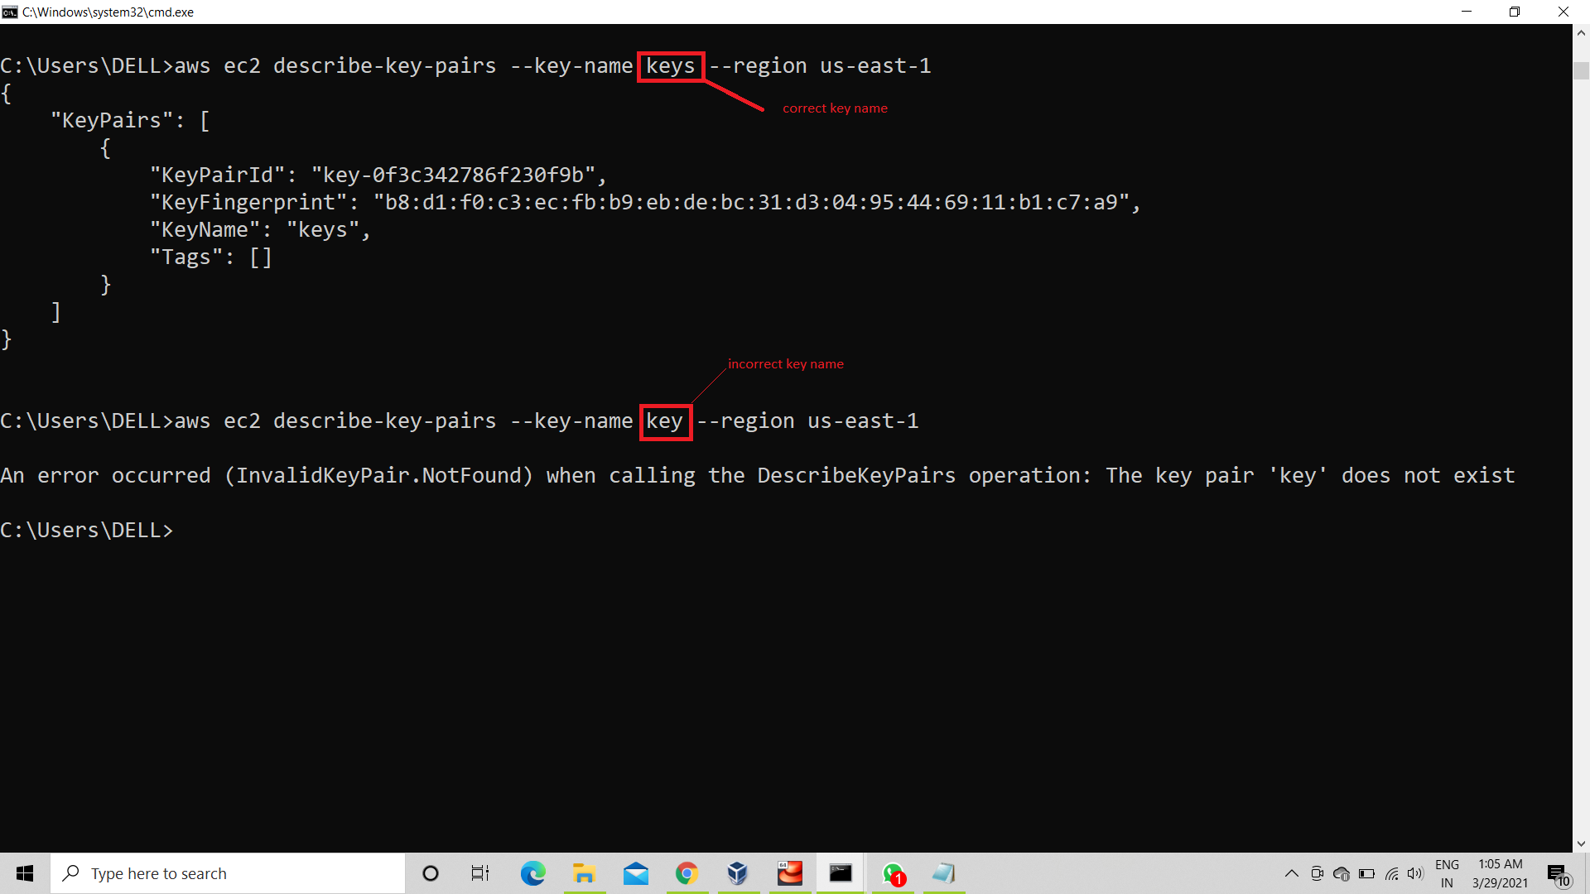

### **2. Create a security group :**

To create any security group to launch ec2 instance , again the must required option is group name and description and region also, if not provided during configuration.

$ aws ec2 create-security-group --group-name mysg1 --description "test group" --region us-east-1

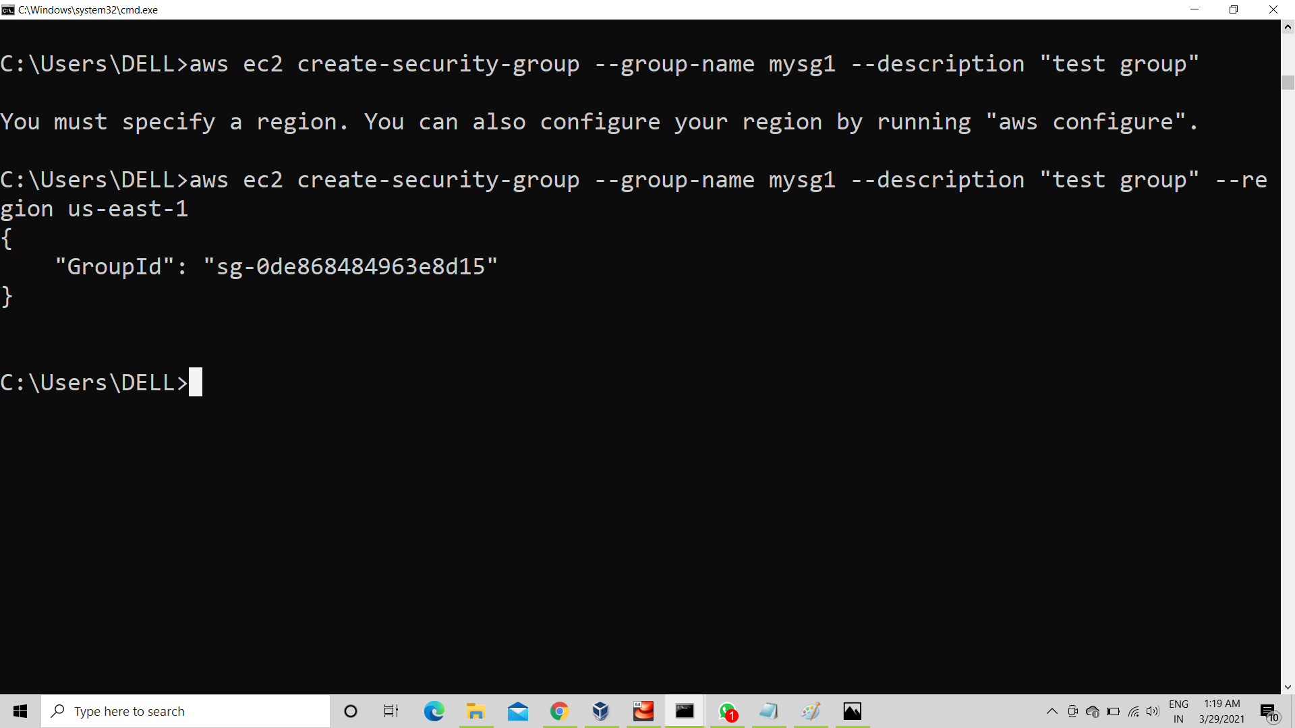

3. Launch an instance using the above created key pair and security group :

To launch any ec2 instance from CLI, we have command run-instances , and it supports so many options, but key-pair name, and image id is the must required option ,so here we will go with minimum option ,i.e key name ,ami , security group name and region, because other all options like machine type , hard disk size etc, it take as by default values if not specified.

$ aws ec2 run-instances --image-id ami-0533f2ba8a1995cf9 --key-name keys --security-group-ids mysg1 --region us-east-1

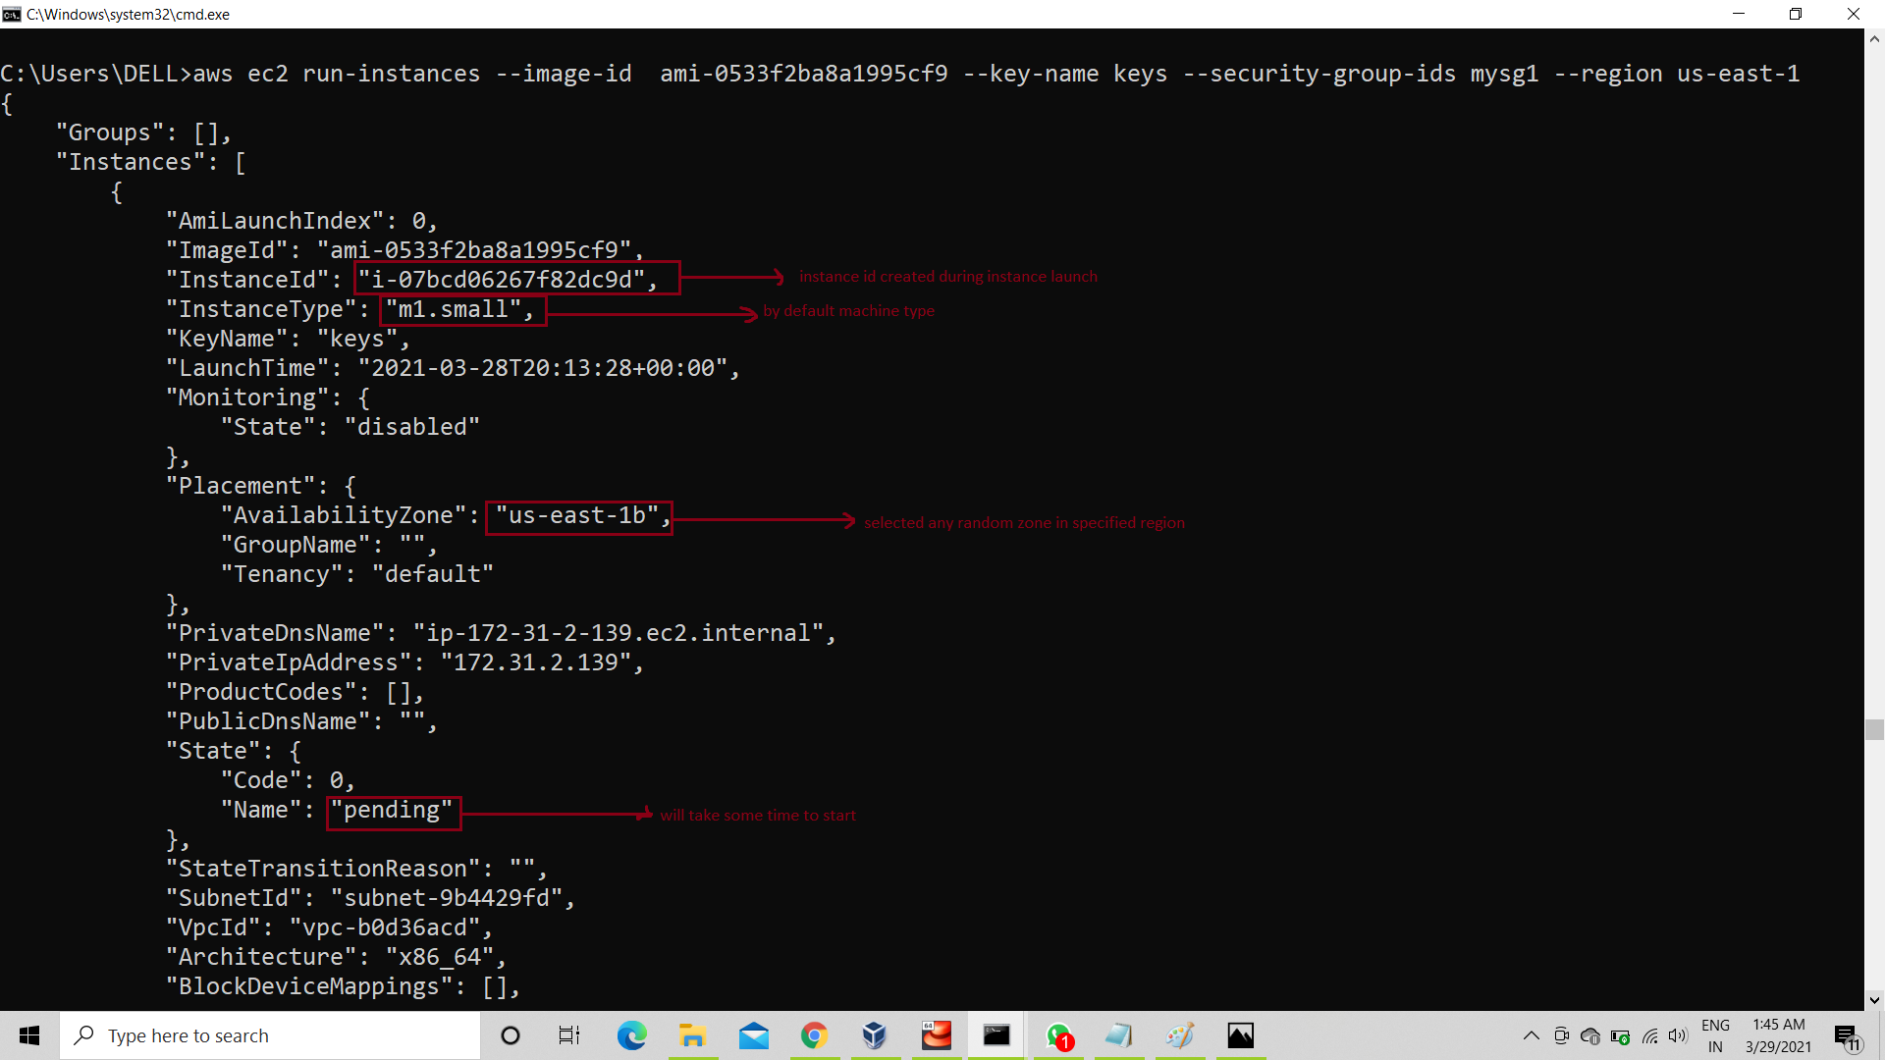

When we launch any instance, it takes few seconds to start , so initially it will show pending status, but we can check whether it started or not after some seconds with describe-instances command, and we have to provide instance id, that we got during launching the instance along with region.

$ aws ec2 describe-instances --instance-ids i-07bcd06267f82dc9d --region us-east-1

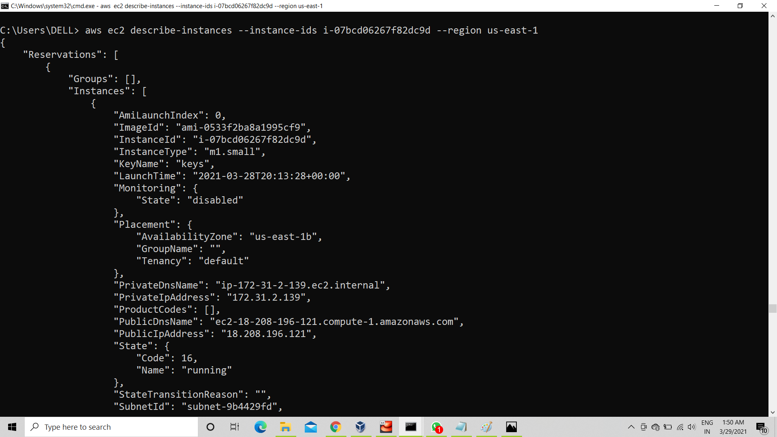

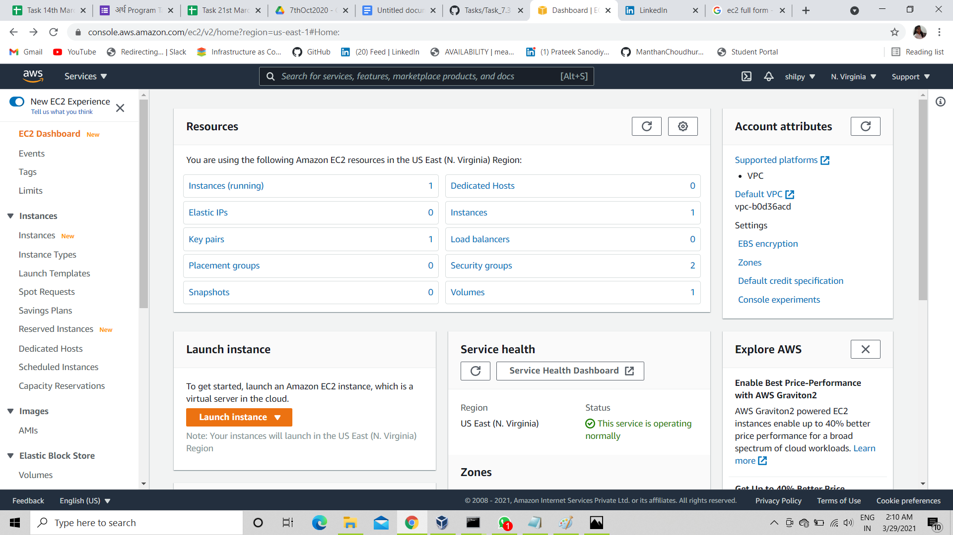

In above screenshot we can see, as we started with 0 instances and all, but now we have created 1 instance, key, security group and 1 volume, but this volume creates itself whenever any instance launch and will get removed with that instance, but if we want to create extra volume and want to attach it to our launched instance manually , then, we have to go with next step:

### **4. Create an EBS volume of 1 GiB :**

To create EBS volume , we have to use command "create-volumes" and EBS volume is zonal service , so we have to provide availability zone, according to our instance. As in our case, by default instance got launched in us-east-1b, so here we are creating volume to attach with the same instance , so we have to provide the same zone, i.e us-east-1b. And mentioning region is must , and more options are there that we can provide as per our need, like size, volume type etc, but here we just want to create EBS volume of 1 GiB to attach to launched instance, so we are not going to mention volume type, so by default (gp2) it will take the volume type.

$ aws ec2 create-volume --size 1 --availability-zone us-east-1b --region us-east-1

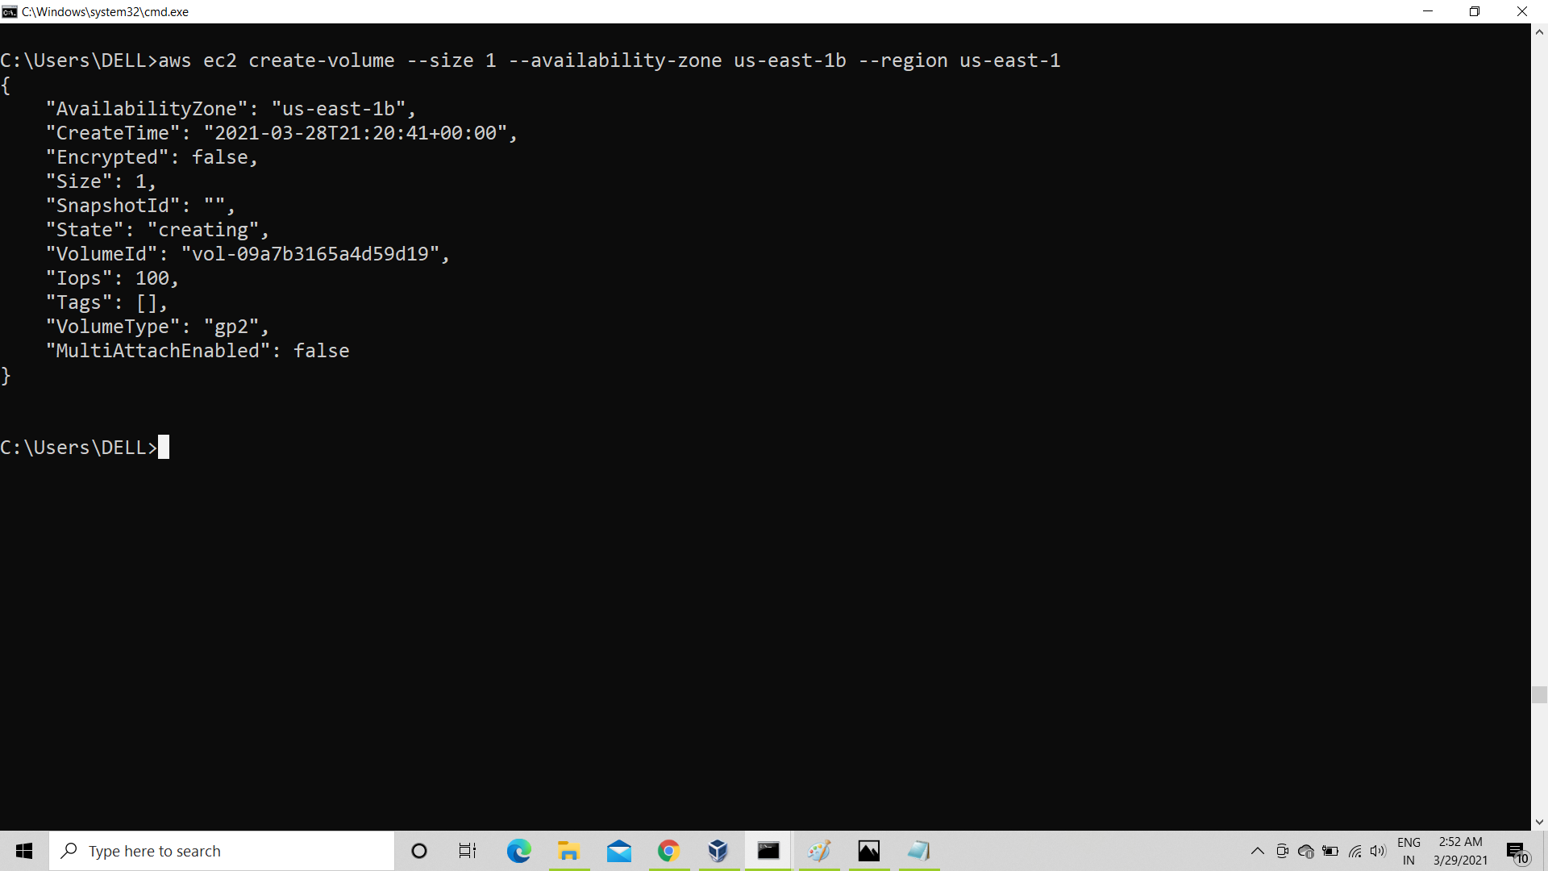

then we can describe the volume with command:

$ aws ec2 describe-volumes --volume-ids vol-09a7b3165a4d59d19 --region us-east-1

5. The final step is to attach the above created EBS volume to the instance you created in the previous steps :

To attach created EBS volume to launched instance, we need to know volume id and instance id and need to mention region for sure also we need to provide device name, means partition name, and for EBS volume devoce name can be either /dev/sdb or /dev/sdc or so on , OR /dev/xvda, or /dev/xvdb or so on, and command for attaching volume to any instance is attach-volume .

Before attaching volume, describe instance

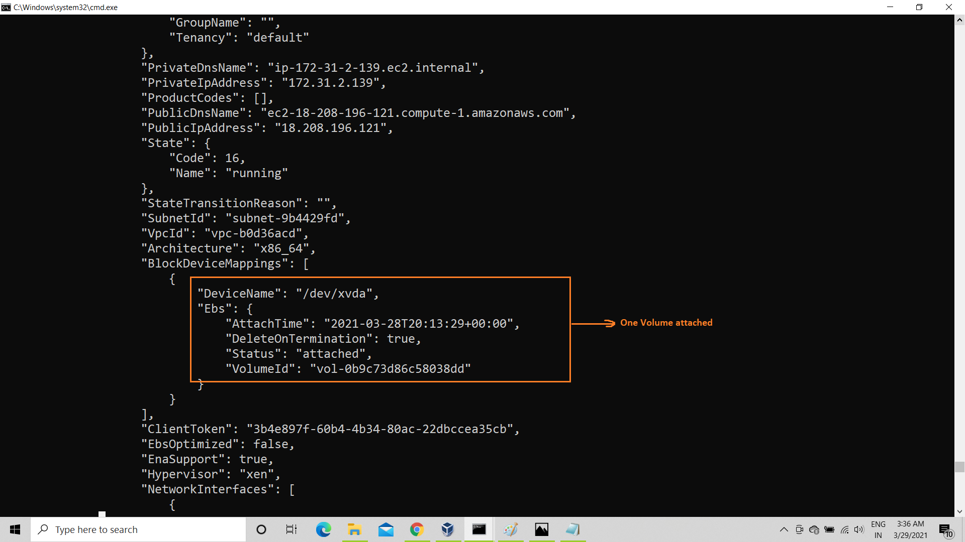

Now attach volume with command:

$ aws ec2 attach-volume --volume-id vol-09a7b3165a4d59d19 --instance-id i-07bcd06267f82dc9d --device /dev/sdb --region us-east-1

After attaching volume, describe instance

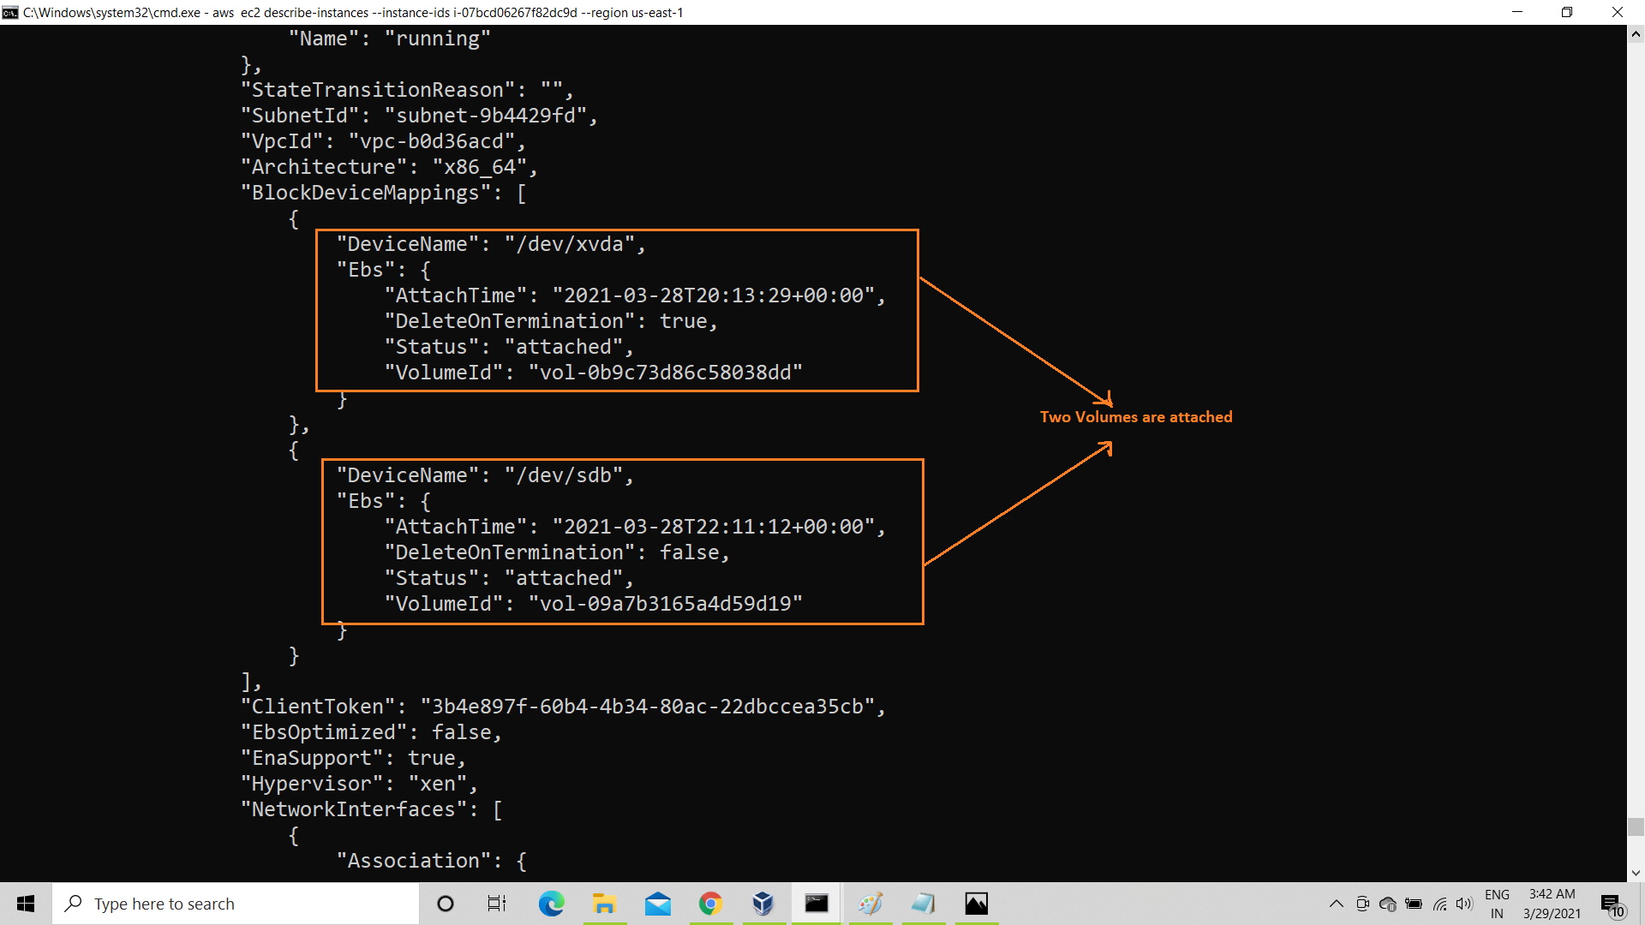

So, finally we are done with all the planned setup , and for any difficulty help command is always there for our help, and this is the final ec2 dashboard of N. virginia

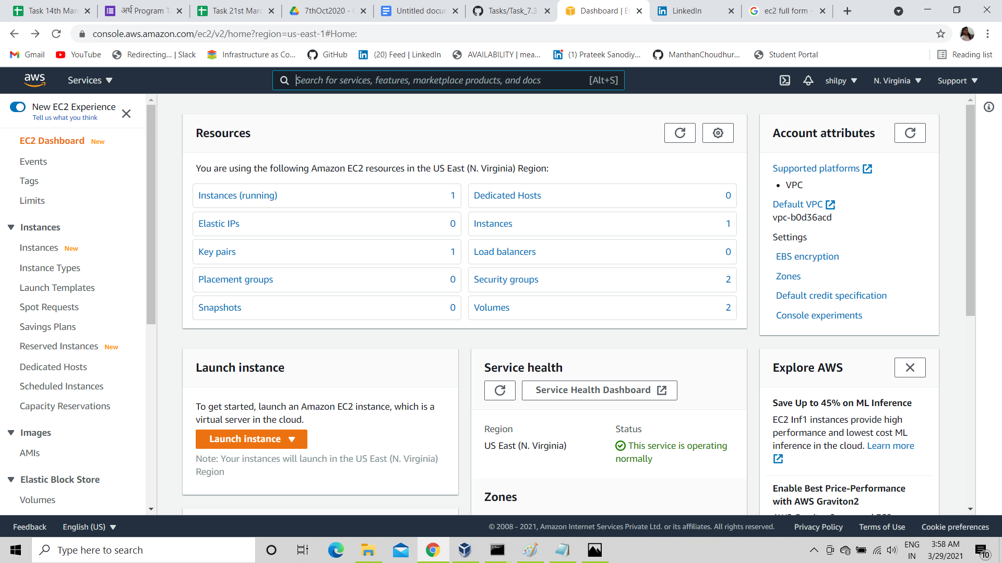

Thank You